**WOLVEY VILLAGE HALL FOUNDATION (CIO)**

**The Square, Wolvey LE10 3LJ**

So British Summer Time is nearly upon us, the clocks spring forward 1 hour at 1am on Sunday 30th March, which will mean more daylight in the evenings, although less daylight in the mornings, in the beginning at least.

So a good opportunity to plan ahead and see what’s on for you at your Village Hall. Although we say farewell to our Soup and Roll lunchtime sessions, there are still plenty of things to do, with more in the pipeline. The Spring Fair will have taken place at the time of this publication, so it will be the May edition before we can let you know how it went (although hopefully most of you attended in person)

**EVENTS HAPPENING IN APRIL**:

On **Friday, 11th April** we have **Yoga, Meditation and Sound Bath with NAOMI,** this will take place in the Main Hall from 7.30pm - 9.00pm at a cost of £15 per person.

The activities will include Yoga Poses suitable for beginners, followed by guided meditation and a soundbath. Remember to bring your Yoga Mat, blanket, pillow and bottled water and to wear loose comfortable clothing.

To book or for more information - Contact Naomi on 07857 916140, or email [naom2travel@yahoo.co.uk](mailto:naom2travel@yahoo.co.uk)

On **Tuesday 15th April**, A Free Event run by Warwickshire County Council Safety Education and the Warwickshire Road Safety Partnership will feature a **Mature Driver Workshop,** which will be held in the Garden Room between 12 noon and 1.00 pm. This will be aimed mainly at those motorists amongst us who require a bit of a technical re-fresh. The session will be very informal and informative and will be carried out as a workshop, covering things such as; driving licence renewal (required every 3 years once you reach 70); mature driver reviews, the highway code, plus more topical issues.

Next up on **Good Friday (18th April)** and in the Main Hall and Garden Room from 10am until Midday is Messy Church and Messy Easter, this is a fun event all about Christ-centered activities for children and parents of all ages based on creativity, hospitality and celebration. The event is run by volunteers from St John the Baptist Church led by Rev Jonny Vaughan (Extra volunteers are always welcome if you wish to help)

Both events are free of charge, however donations on entry will be very much appreciated.

On **Sunday 27th April** we are having another visit from Naomi with a session of **Meditation and Soundbath**,this will take place in the Main Hall from 11.30am – 12.30pm at a cost of £12 per person.

Booking and contact details are the same as above.

Nudging into **May (Fri 2nd)** we have our usual charity coffee morning, with a slight difference as the Village Hall supports the start of the VE Day celebrations. We will have a VE Day themed coffee morning with street party style table-layout in the hall, with flags and bunting, the nominated charity is also supportive of the VE Day with a half share going to the:

There will be a further VE Day event on Thurs 8th May (details to follow)

More details for all of the above can be found on our Facebook page.

**WHAT WE HAVE BEEN UP TO OVER THE PAST FEW WEEKS**:

Our **Quiz night on Saturday 22nd February** was extremely well attended, in fact it was a full hall, with 19 tables of Quizzers all enjoying a great night, hosted by Lee, with Quizzers bringing their own nibbles and drinks. There was a great mix of people and a lot of general, music & film knowledge present on the night, it was an evening of fun and some guesswork with prizes being awarded for each round winner and a main prize for the overall winner.

On **Friday 7th March, the Nrithyam School of Dance** were hosting an evening of dance and dinner to celebrate National Women’s Day, where the ladies of the village were invited to have a table and join in with the festivities. So there were 7 ladies from the village who all paid their £23 to partake in the dancing and eating and join in with an evening of energy and colour. The evening started off with some mesmerising Indian Dance performances from performers from all areas of the country, alongside music by the Groovy DJ. This was followed by a “Fun Dance Workshop” where the ladies were made extremely welcome to join in the dancing, there was even a performance from them on stage. Cocktails followed, which were very nice, as was the lovely food, even if some dishes may have been a little on the hot ‘n’ spicy side.

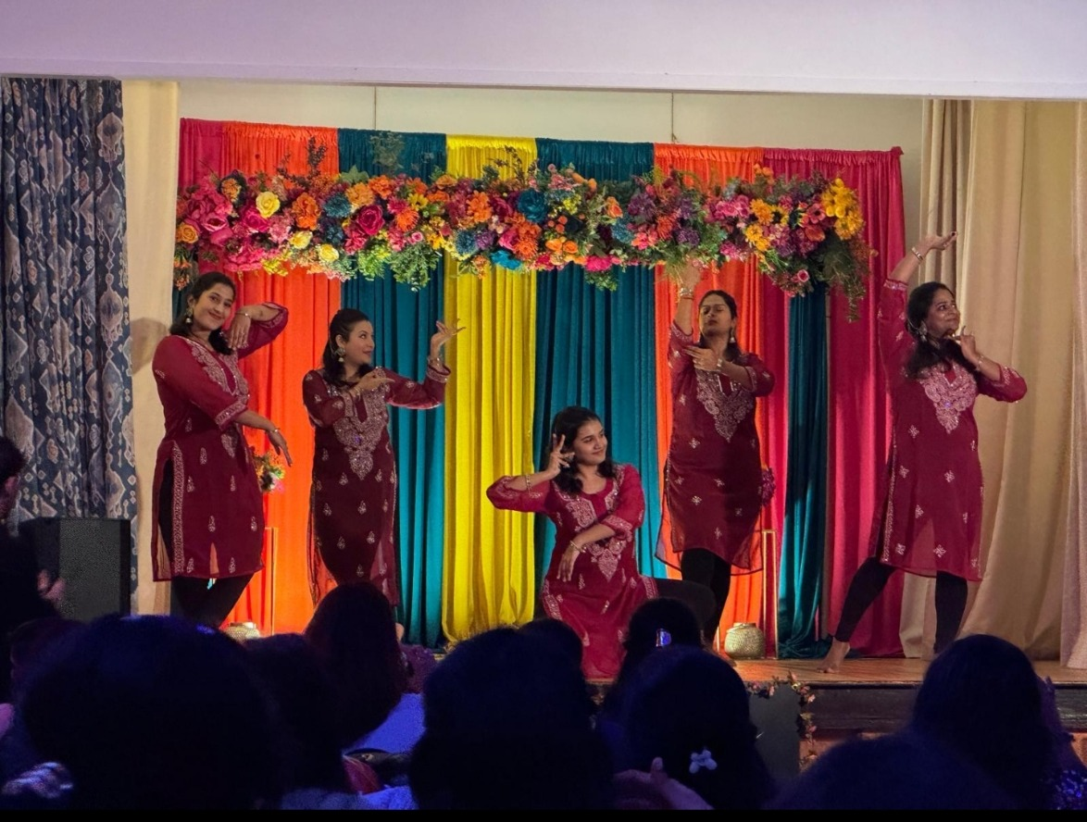

**MONTHLY COFFEE MORNINGS**

Our nominated charity for the Coffee Morning on 7 March was **Doorway, Nuneaton** a charity providing advice support and development to tackle all aspects of social disadvantage including poor housing. The event raised £458.60 which was to be shared with Doorway (after deduction of £48 Hall running costs). We also collected a lot of household goods, which were delivered to Doorway’s collection centre in Dugdale Street, Nuneaton. Other organisations attending the coffee morning were Richard from Warwickshire Rural Community Council (WRCC) who was promoting Warm Hubs and other services they provide, Adrian Warwick from the Parish Council, and two PCSO’s who chatted with residents.

The upcoming **4 April Coffee Morning** funds raised will be shared between the Village Hall and Warwickshire & Solihull Bloodbikes who are often delivering life-saving supplies.

The Village Hall Coffee Mornings are held on the first Friday of each month between 10.30am and 12.30pm, and everyone is welcome. Mini Explorers for babies, pre-school children and their carers is held in the Garden Room and is a great way to make new friends or spend time with old friends.

**EASY EXERCISE CLASSES**

Although the Soup and Roll has ended, our Easy Exercise classes are still going strong every Tuesday, and these are followed by tea, coffee and biscuits for all those who wish to stay. Please be aware that due to the fact that the funding attracted from Warm Hubs came to an end on the 31st March, there will now be a charge of **£3** per person going forward.

**VOLUNTEERING**

Wolvey Village Hall is a registered Charity run by volunteers. We have a great team but additional volunteers are always welcome, particularly for our monthly Coffee Mornings. If you would like to join us please get in touch by email (below) or speak to one of the volunteers or Committee Members at any of our events. It’s a great way to meet new people and put something back into your community.

**ROOM HIRE AND EVENTS**

If you are looking for a venue for your class, group or event please visit our website [www.wolveyvillagehall.co.uk](http://www.wolveyvillagehall.co.uk) for further details (scroll down the pages to see all the information). We offer special rates with generous discount for regular groups which are open to the public and benefit the community (please enquire for details). If you wish to view the venue or have further queries, please contact us at [admin@wolveyvillagehall.co.uk](mailto:admin@wolveyvillagehall.co.uk).

Availability of rooms, hire charges, terms and conditions and all our policies may be found at our website.

Contact us: [www.wolveyvillagehall.co.uk](http://www.wolveyvillagehall.co.uk) [admin@wolveyvillagehall.co.uk](mailto:admin@wolveyvillagehall.co.uk)

<https://www.facebook.com/wolveyvillagehallfoundation>

**Wolvey Village Hall Foundation CIO - Charity No. 1193439**